**Name : SHRUTI SHRINIVAS MORE**

**ASSIGNMENT NO : 4**

**Implementation of Linear Search**

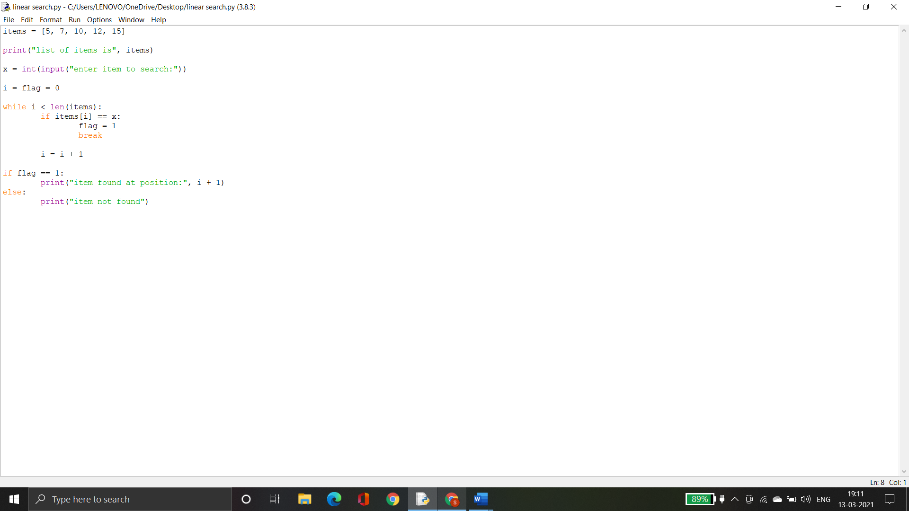

**OUTPUT :**

